Excel Tips

Filling the Gaps in a Report

At times, we have reports or data that does have some gaps and the same though appropriate for better presentation is not useful if we want to analyse the data, because the blank cells create an issue when we want to sort or manipulate data for analysis.

For example, we have a report like this.

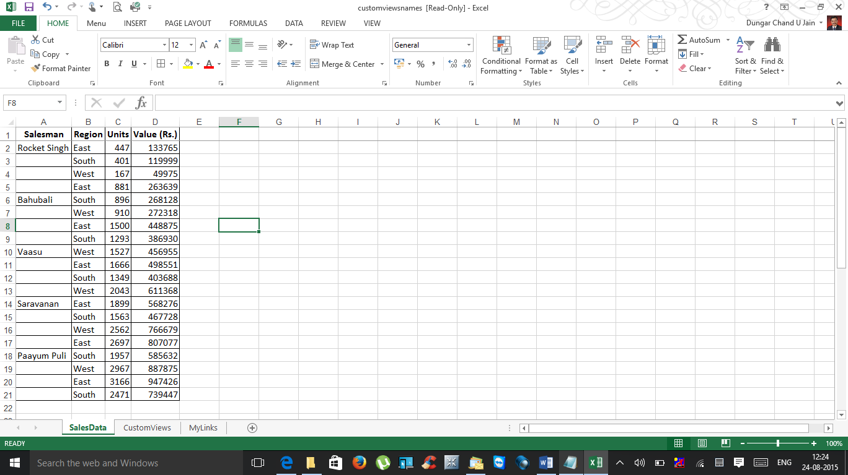

At times when we have a report generated like this or someone sends us data like this where an entry in column A applies to several rows of data. If we sort or filter this type of list, the missing data messes things up, and we can no longer tell who sold what.

If the above list is small, we can enter the missing cell values manually or by using a series of Home➜ Editing➜Fill➜Down commands (or its Ctrl+D shortcut).

But if we have a large list that’s in the above format, we need a better way of filling in those cell values. Here’s how we can fill these gaps in the report.

1. Select the range that has the gaps (A2:A21, in the above example).

2. Choose Home➜Editing➜Find & Select➜Go to Special to display the Go To Special dialog box.

2a. Alternatively, We can use Ctrl+G, which will open this dialog box and then we may click “Special”

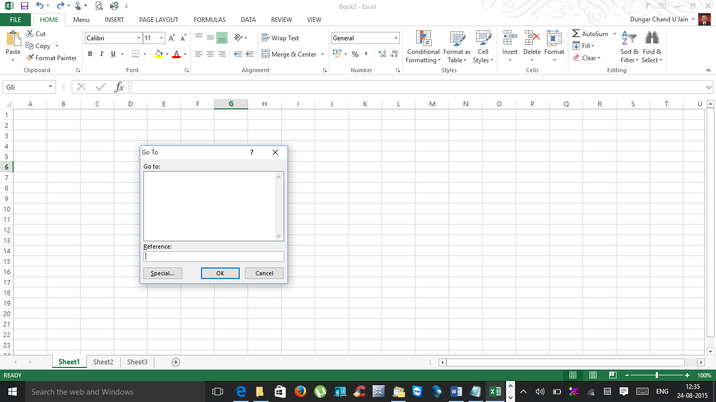

3. In the Go To Special dialog box, select the Blanks option and click OK.

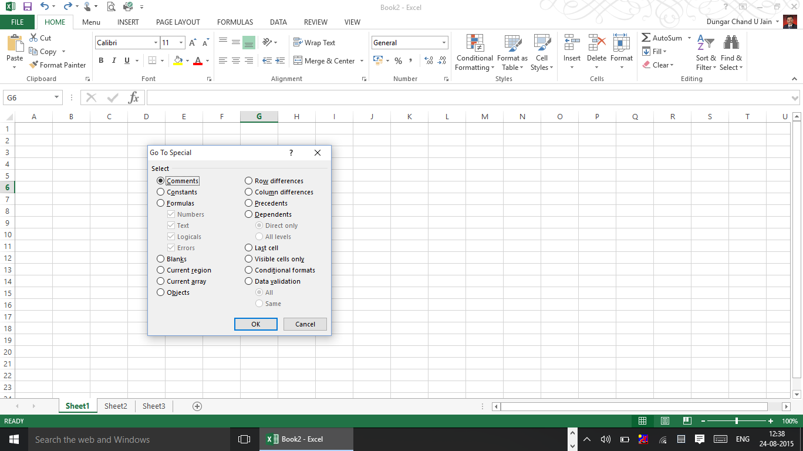

4. This action selects the blank cells in the original selection like this

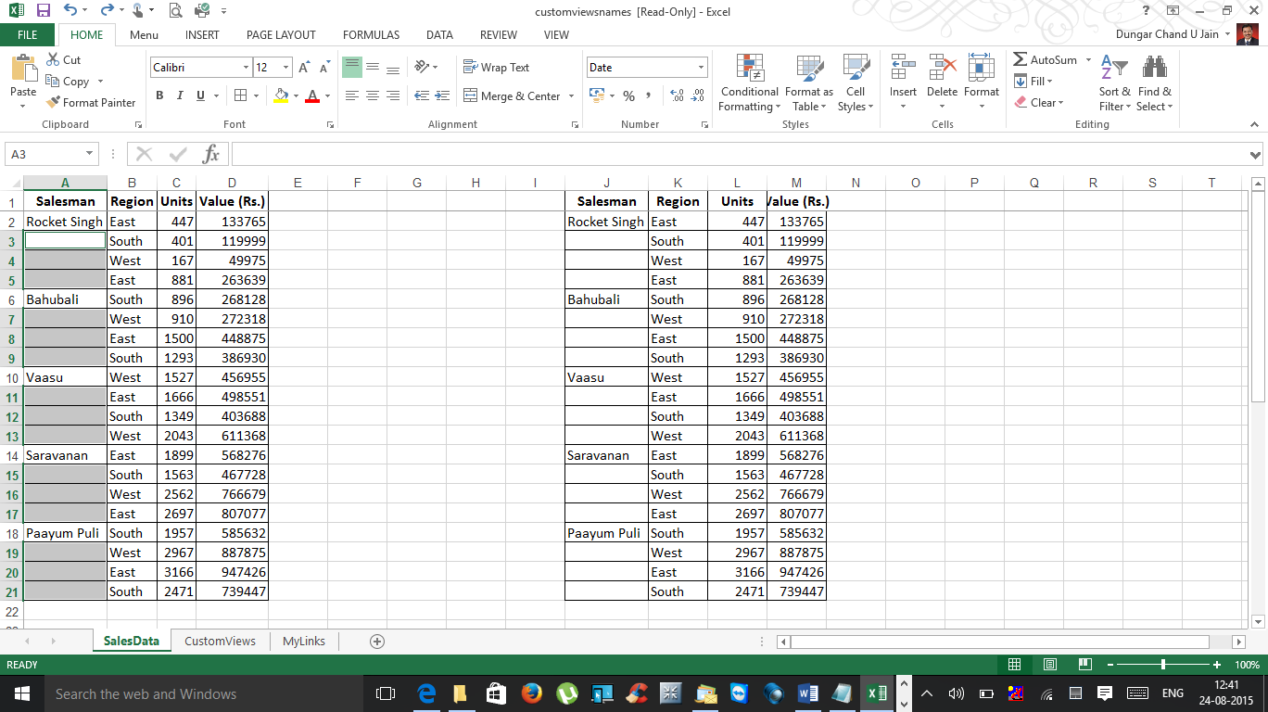

Caution : Do not click mouse button / tap any key as you proceed.

5. On the Formula bar, type an equal sign (=) followed by the address of the first cell with an entry in the column (=A2, in this example) and press **Ctrl+Enter**.

6. We have almost got what we want but the data has only formula instead of data.

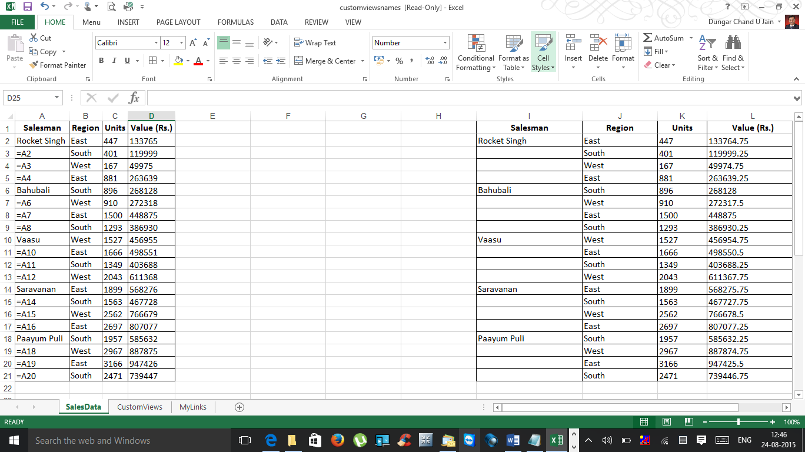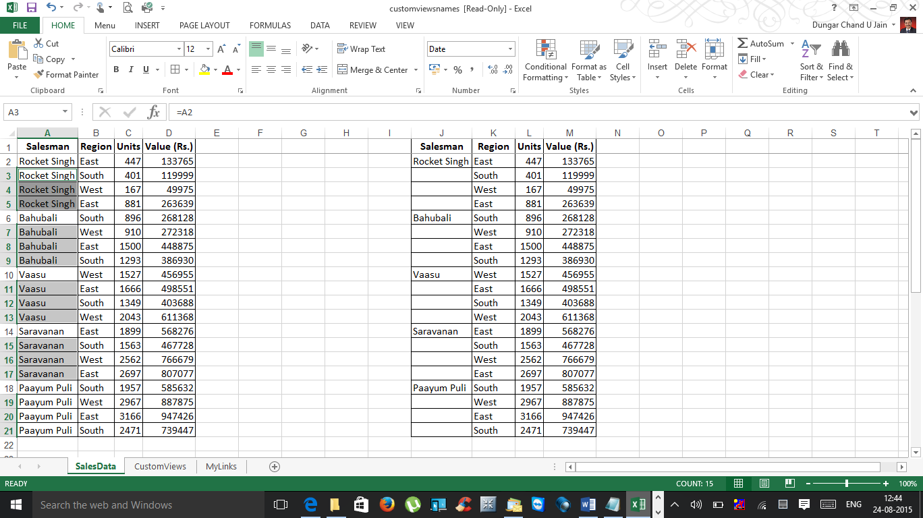

6. Reselect the original range and press Ctrl+C to copy the selection.

7. Choose Home➜Clipboard➜Paste➜Paste Values to convert the formulas to values.

After we complete these steps, the gaps are filled in with the correct information, and the worksheet thus contains only data and we can do whatever we like with it — including sorting.

***-CA Dungar Chand U Jain, Madurai (dcjain@icai.org)***